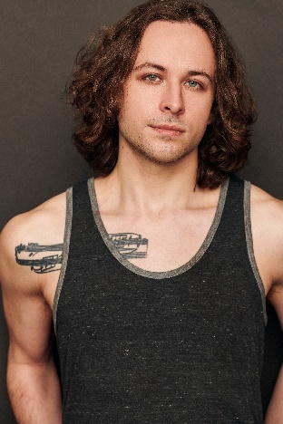
Brian Hirsch
Brianhirsch43@gmail.com
Brianhirschactor.com
Range: G2 – Db5
Hair: Brown Eyes: Blue Height: 5’8’’

REGIONAL THEATRE:

NEWSIES Jack Kelly Weathervane Playhouse, Akron, Ohio

GODSPELL George Porthouse Theatre
ALTAR BOYZ Swing (Matt, Mark, Luke, Abe) Porthouse Theatre
HEATHERS HAIRSPRAY CINDERELLA  LAST 5 YEARS  EDUCATIONAL THEATRE: | J.D.  Link Larkin Prince Charming  Jamie | Western Reserve Playhouse Weathervane Playhouse, Akron, Ohio  Weathervane Playhouse, Akron, Ohio  Avenue Arts
HAIR | Claude | Kent State University
35MM | Man 1 | Kent State University
ANY RESEMBLANCE | Stanley Curson | Kent State University
CHAINING ZERO | Mike | Kent State University
GHOST | Sam Wheat | ASA
Cabarets:
54 Sings Teen Angst (Jan ’23)

FILM:
APNEA | Lead | Nick Romito, dir.

WORKSHOPS/TRAINING
Kent State University, BFA Theatre LINK Class 1
LINK Class 4
Private voice study; Classical (9 years), Jazz (4 years)
Dance (proficient in); Ballet, Jazz, Modern, Hip-Hop, Tap

SKILLS:
Guitar, Piano, Cross Country, Intermediate Japanese, Painting/Drawing, Driver’s License, can grow full beard

